How to Open a Shared Room or Equipment Calendar

- On the Calendar Tab, select “Open a Shared Calendar” on the left menu bar.

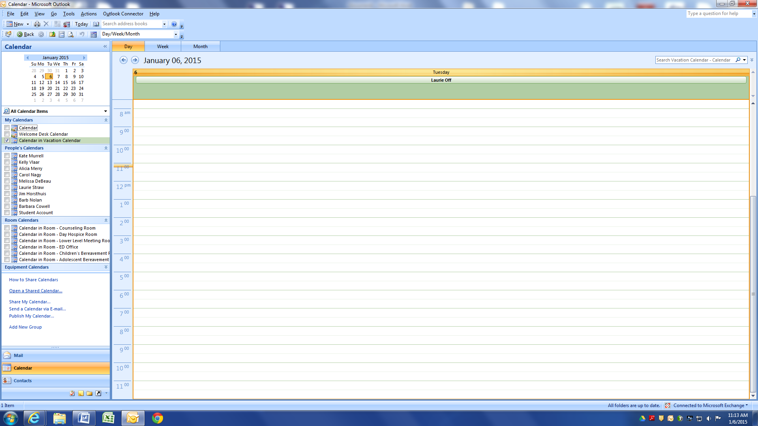

- Select “Name” on the menu box that appears to search for the Calendar for which you would like to gain access and view.

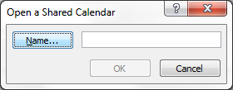

- To open a Room calendar, open the Contacts drop down menu and select “All Rooms”
To open the Equipment calendars or to share another individual’s calendar, select “Global Address List”
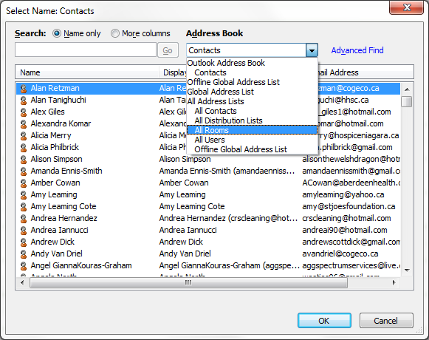

- Select your preferred Room Calendar and select OK. The room calendar will now appear with your list of calendars, and you will have access to view, edit and delete bookings.
